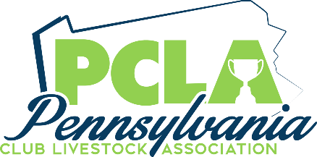

Pennsylvania Club Livestock Association
Evan Vonada Memorial Grant
Lucas Hayman Memorial Grant

Two $1,000 Grants
Deadline for all applications June 1, 2023
Winner will be announced at the PCLA Annual Banquet August 5, 2023
Please contact Jason McGinnis at 724-787-5572 or jason.mcginnis@resfuel.com with any questions
Qualifications
- You must currently be attending college or a trade school.
- Must be a current or former PCLA member
Applicant Information
Full Name
Home Address
City | State |  | Zip
Email
Home Phone: |  | Cell Phone:
Birth Date
Name(s) of Parent/Guardian
- Under the age 23 as of January 1, 2023
College Information
School Name
School Address
City | State | Zip
Major:
Degree you will receive:
GPA | Anticipated Graduation Date

Pennsylvania Club Livestock Association
Evan Vonada Memorial Grant
Lucas Hayman Memorial Grant

Name _________________________________________________________
Academic Achievements
1
2
3
4
5
6
Community Service
1
2
3
4
5
6
Livestock Awards/Accomplishments
1
2
3
4
5
6

Grant Requirement
1. Complete entire application (attach additional pages if required)
2. Include one (1) page essay explaining how showing livestock has impacted your life.
3, Attach a copy of your Spring 2023 semester schedule or transcript

Send completed application with all required documents to the address below.
Must be postmarked by June 1, 2023.
PCLA Evan Vonada/Lucas Hayman Memorial Grants
c/o Jason McGinnis
3775 Rayne Church Road
Indiana, PA 15701

